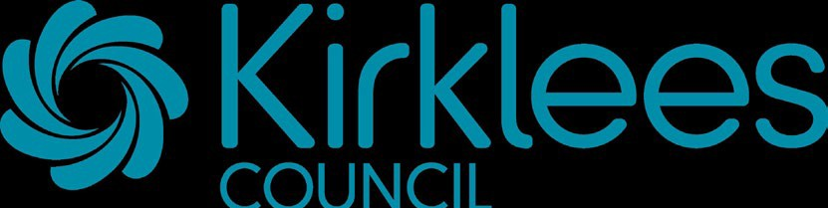
Weekly Menu: Ethos 2022-23 - Wk 1

Monday | Tuesday |  |  | Wednesday |  |  | Thursday |  |  | Friday
Main Main |  |  |  | Main |  |  | Main |  |  | Main
Quorn Dippers | Chicken Tikka Masala |  |  | Roast Of | The | Day | Homemade Sausage Rolls  Pie |  |  | Harry Ramsdens Battered Fish
Savoury Mince | Home Made Loaded Pizza |  |  | Cheese & Onion Quiche |  |  | Pasta served with  Tomato & Basil Sauce |  |  | Quorn Rogan Josh Curry with Rice
Jacket Potato With Cheese | Jacket Potato With Cheese |  |  |  |  |  | Jacket Potato With Cheese |  |  | Pizza Panini
 |  |  |  | Jacket Potato with Cheese & Coleslaw
Jacket Potato with Tuna Mayo | Jacket Potato with Tuna Mayo |  |  |  |  |  | Jacket Potato with Crunchy Coleslaw
 |  |  |  |  |  |  |  |  |  | Jacket Potato With Cheese
Tuna Salad | Cheese Salad
 |  |  |  | Jacket Potato With Beans
 |  |  |  |  |  |  | Egg Salad |  |  | Jacket Potato with Tuna Mayo
Pizza Panini | Tuna Melt
 |  |  |  | Tuna Salad
 |  |  |  |  |  |  | Ham Sandwich |  |  | Ham Salad
Cheese & Garlic Panini | Cheese & Tomato Panini
 |  |  |  | Cheese Salad
 |  |  |  |  |  |  | Pizza Panini |  |  | Cheese & Ham Panini
Egg Mayonnaise Sandwich | Tuna Sandwich
 |  |  |  | Tuna Panini
Dessert | Dessert |  |  | Dessert |  |  | Dessert |  |  | Dessert
Fruity Pot | Sponge with Custard |  |  | Fruit Muffin |  |  | Apple Crumble with Custard |  |  | Fruit Muffin
Victoria Sponge with Custard | Fruity Flapjack & Juice |  |  | Cupcakes |  |  | Apple Crumble - No Custard |  |  | Fruit Scone
Victoria Sponge - No Custard | Yoghurt |  |  |  |  |  | Fruity Pot |  |  | Fresh Fruit Platter
 | Fresh Fruit Platter

Allergens
Cheese & Garlic Panini: Cereals containing gluten, Milk, Sesame seeds, Soya; Ice cream: Milk; Chocolate Slab Cake: Cereals containing gluten, Eggs, Milk; Orange Victoria Sponge: Cereals containing gluten, Eggs, Soya; Ham Panini: Cereals containing gluten, Sesame seeds; Harry Ramsdens Battered Fish: Cereals containing gluten, Fish; Jacket Potato with Cheese & Coleslaw: Eggs, Milk, Mustard; Syrup Sponge with Custard: Cereals containing gluten, Eggs, Milk, Soya; Rice Pudding: Milk; Yoghurt: Milk; Fruit Scone: Cereals containing gluten, Eggs, Milk, Sulphur Dioxide; Cheese Salad: Milk; Apple Crumble with Custard: Cereals containing gluten, Eggs, Milk; Apple Crumble - No Custard: Cereals containing gluten; Syrup Sponge - No Custard: Cereals containing gluten, Eggs, Milk; Pizza Panini: Celery, Cereals containing gluten, Eggs, Milk, Soya; Cheese & Ham Panini: Cereals containing gluten, Milk, Soya; Cheese & Tomato Panini: Celery, Cereals containing gluten, Milk, Soya; Tuna Melt: Cereals containing gluten, Fish, Milk, Mustard, Soya; Quorn Sausage Roll: Cereals containing gluten, Eggs, Milk; Cupcakes: Cereals containing gluten, Eggs, Milk, Soya; Minced Beef Pie: Cereals containing gluten, Eggs; Tuna Salad: Eggs, Fish, Milk, Mustard; Jacket Potato With Cheese : Milk; Ham Sandwich: Cereals containing gluten, Milk; Cheese Sandwich: Cereals containing gluten, Milk; Fruity Falpjack & Juice: Cereals containing gluten, Nuts, Peanuts, Soya, Sulphur Dioxide; Quorn Dippers: Cereals containing gluten, Eggs; Egg Mayonnaise Sandwich: Cereals containing gluten, Eggs, Milk; Jacket Potato with Tuna Mayo: Eggs, Fish, Milk, Mustard; Penne Pasta with Italian Sauce: Cereals containing gluten, Eggs; Quorn Balti: Eggs; Jacket Potato with Crunchy Coleslaw: Eggs, Milk, Mustard; Vegetable Lasagne: Cereals containing gluten, Milk; Home Made Loaded Pizza: Cereals

containing gluten, Eggs, Milk, Soya; Roast Of The Day: Cereals containing gluten, Eggs, Milk, Soya; Homemade Sausage Roll: Celery, Cereals containing gluten, Eggs, Mustard, Soya, Sulphur Dioxide; Tea Loaf : Cereals containing gluten, Eggs, Milk, Nuts, Peanuts, Soya, Sulphur Dioxide

